 | 
Laboratory 2: Integration of Sensors with ESP32 | School of Applied Digital Technology
Name:  Name: | ID:  ID: | Section:  Section:
Date: | Due date:

Objectives:
- Learn how to wire the DHT11 and MQ-2 sensors to the ESP32 board.
- Understand the basic setup and configuration using ESPHome.
- Test and view sensor data through Home Assistant.

Experiment 1: Integration of Sensors with ESP32
Equipment:
Quantity
ESP32 1
Fan Motor 1
DHT11 Sensor 1

- Wiring the Sensors to the ESP Board

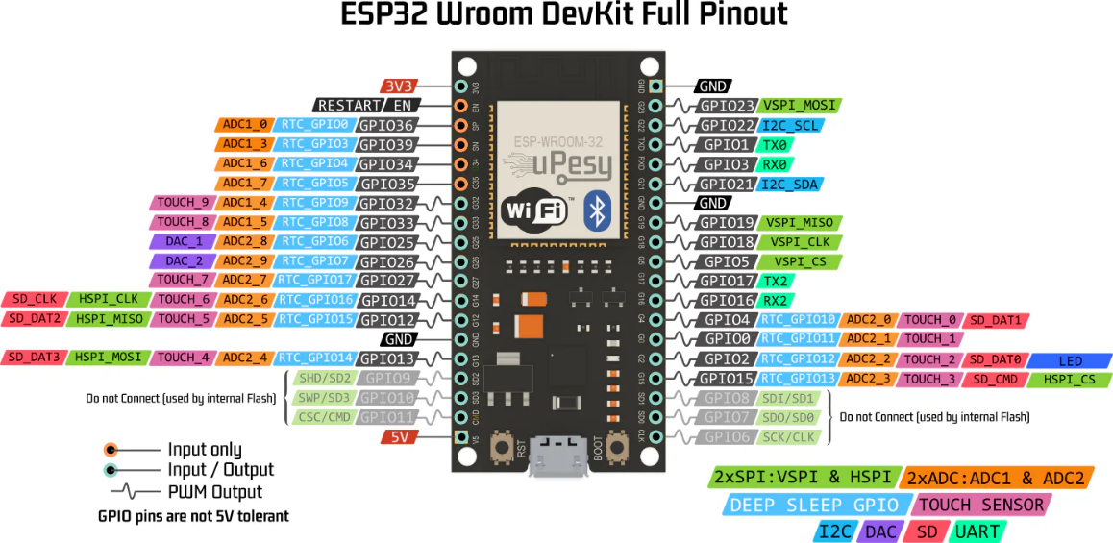

- DHT11 (Temperature and Humidity Sensor)
• VCC → 3.3V
• GND → GND
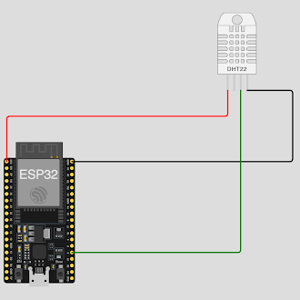
• DATA → GPIO22

- Fan Motor
• VCC → 3.3V
• GND → GND
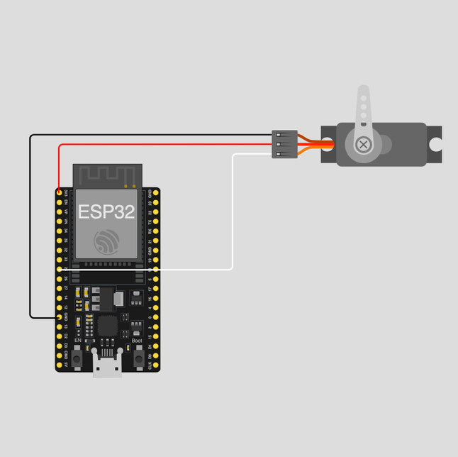
• DATA → GPIO25

- Open ESPHome and Select the Device
  - Go to the ESPHome Dashboard
  - Select your device (e.g., sensor)
  - Click EDIT to modify the YAML configuration

- Add Code for the Sensors in the YAML File
Add the following to your configuration file:
  - DHT11 (Temperature and Humidity Sensor)
sensor:
- platform: dht
pin: 22
model: DHT11
temperature:
name: "Temperature"
id: temperature
unit_of_measurement: "°C"
humidity:
name: "Humidity"
id: humidity
unit_of_measurement: "%"
update_interval: 10s

  - Fan Motor
output:
- platform: ledc
pin: 25
id: fan_pwm
frequency: 25000 Hz
inverted: true

fan:
- platform: speed
name: "DC Fan"
output: fan_pwm
speed_count: 100
restore_mode: ALWAYS_ON

- Save and Install the Firmware
- Click SAVE
- Click INSTALL
- Choose Wirelessly or USB depending on your setup
- Wait for the upload to complete and let the device reboot

- View Sensor Data in Home Assistant
- Go to your Home Assistant Overview Dashboard
- You should now see sensor readings such as:
- Temperature / Humidity from DHT11
- Gas Detection Level from MQ-2

Take 1: Design and Build an Automated Fan Control System Using Temperature and Humidity Sensors.
Requirements:
1. Use an ESP32/ESP8266 board and a DHT11 sensor.
2. Connect a DC fan controlled via PWM (LEDC) to allow variable fan speed.
3. Read temperature and humidity every 10 seconds.
4. Combine the sensor reading and fan control code into a single ESPHome YAML file.
5. mplement automation so the fan operates according to the following conditions:
• Temperature ≥ 30°C → Fan runs at 100% (full speed)
• Temperature < 27°C → Fan turns OFF
6. Display temperature and humidity values in Home Assistant.
Home Assistant Dashboard:

Code:

----- Have a good day -----

Answer:
sensor:
- platform: dht
pin: 22
model: DHT11
temperature:
name: "Room Temperature"
id: temperature
unit_of_measurement: "°C"
humidity:
name: "Room Humidity"
id: humidity
unit_of_measurement: "%"
update_interval: 10s

output:
- platform: ledc
pin: 25
id: fan_pwm
frequency: 25000 Hz
inverted: true

fan:
- platform: speed
name: "DC Fan"
id: dc_fan
output: fan_pwm
speed_count: 100
restore_mode: ALWAYS_OFF

interval:
- interval: 10s
then:
- lambda: |-
if (id(temperature).has_state()) {
float t = id(temperature).state;

if (t >= 30.0) {
id(dc_fan).turn_on(); // เปิดพัดลม
id(dc_fan).speed = 1.0; // ตั้งความเร็ว 100%
} else if (t < 27.0) {
id(dc_fan).turn_off(); // ปิดพัดลม
}
}

